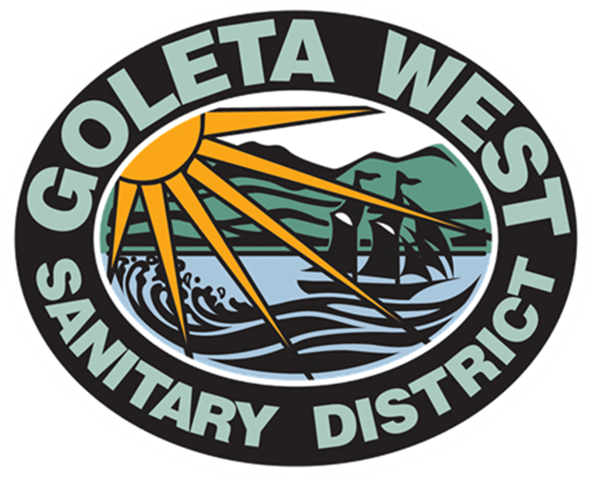
Goleta West Sanitary District

P.O. Box 4
Goleta, CA 93116-0004

(805) 968-2617
(805) 562-8987
www.goletawest.com

For Immediate Release Contact: Mark Nation
October 24, 2011 (805) 968-2617

Pipeline Capacity Project Completed in Isla Vista

Goleta, CA – Goleta West Sanitary District has completed the replacement of a large section of sewer line in Isla Vista along Embarcadero Del Norte Road between Pardall and Trigo Roads. This project allows the District’s sewer system to meet the capacity requirements of existing users and new developments in the area.

Motorists, bicyclists and pedestrians experienced minor inconveniences during the summer construction phase.

The District replaced over 800 feet of existing sewer mainlines with larger lines to accommodate projected demands for wastewater capacity resulting from two recently approved mixed-use projects: “The Icon at UCSB,” located at 6545 and 6547 Trigo, and “The Loop,” located at 6533 Trigo. Together, they will add 47 new residential units, 23 hotel rooms and approximately 14,500 square feet of commercial space to the area.

Two local firms, MNS Engineers (providing engineering services and construction management services) and Lash Construction (providing construction services) were contracted to complete the project.

“Our District has been around for nearly six decades. As the western Goleta Valley and Isla Vista have grown, so has our system,” stated Mark Nation, General Manager GWSD. “These types of pipeline projects are necessary to keep up with ever increasing demands on our infrastructure. It is our policy to plan for such upgrades well in advance of residential or commercial development coming online,” Nation added.

Formed in 1954 the Goleta West Sanitary District provides wastewater collection and treatment to over 32,000 customers in the western Goleta Valley and Isla Vista. Over the years the local government agency has been able to plan for projects such as the Embarcadero Del Norte project and the wastewater treatment plant upgrade (currently under construction) by setting aside money to fund these expensive and important improvements. Subsequently, customers see some of the lowest rates in the area and the District has won several local and state awards for operation and maintenance of its sewer collection system.

##

